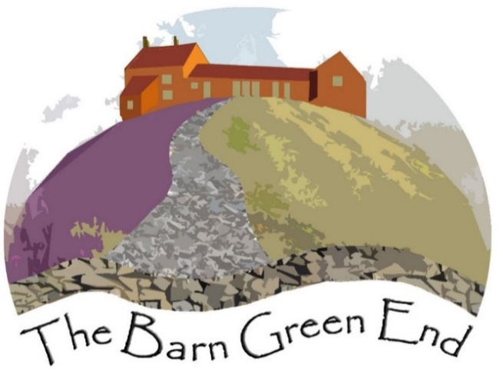
How we will operate during the Covid 19 pandemic
We are looking forward to welcoming you to our lovely, newly renovated Barn. Below are the procedures we have put in place to help keep you safe during your stay. Government guidelines will be followed and adapted where necessary.
This includes the following:
- Allowing additional time for the cleaning to take place. This does mean that we need to ask our guests to check in at the later time of 5pm and check out earlier at 9am.
- We use appropriate PPE for cleaning the property and follow government advice on the correct and safe protocol for ‘donning’ and ‘doffing’ cleaning equipment.
- Government guidelines will be followed to report and manage any potential or confirmed infection cases. It is essential for guests to report any signs of illness immediately.
- We designed the Barn to be an easy to clean, minimal clutter space, but any items difficult to clean will be removed. We will not be supplying a visitors book and welcome packs will be carefully chosen. We intend to have a week on week off rota for items such as cushions, books, maps and leaflets, board games are available on request.
- Deploying extra hygiene measures, including disinfecting high contact areas.

Your role in staying safe
We have supplied hand sanitiser and bars of soap and recommend washing your hands each time you enter or leave the property. Our bins are recycled by John Noble in Ruswarp and nothing goes to land fill. All your rubbish can be put in the same bin but we ask that you bag any waste such as tissues and wipes, sanitary waste and nappies in the small bin bags provided before putting them in the main bins in the car park.
If you have any questions regarding the Barn, please text or call if possible as we are unable to enter the barn during your stay except in an emergency.
It is essential for guests to report any signs of illness immediately. Customers must contact us prior to arrival if they have symptoms of Covid 19 or have been asked to self isolate due to a confirmed or suspected Covid contact, to discuss the options available

Before your departure
We ask that you strip your bed linen and pop it in the pillow cases. The same applies with the towels in a separate pillow case please.
Wash all your plates, bowls, pots and pans and cutlery in hot soapy water and leave to dry.
Please leave all windows open when you depart.
Please empty all bins into outside bins in the car park.
Just a reminder to leave by 9am

Thank you for your understanding and co operation with regards to these updates and changes

